Edge Intelligence LAB
Ashish Vikas Nikam
25MML0015
Jupiter Code For Image Dataset: url = "https://storage.googleapis.com/mledu-datasets/cats_and_dogs_filtered.zip"
Code Fixed and Output:
Loading the Libraries and Dataset:
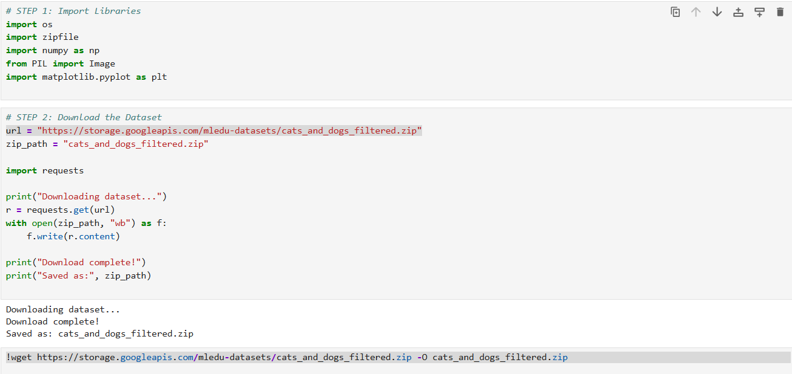
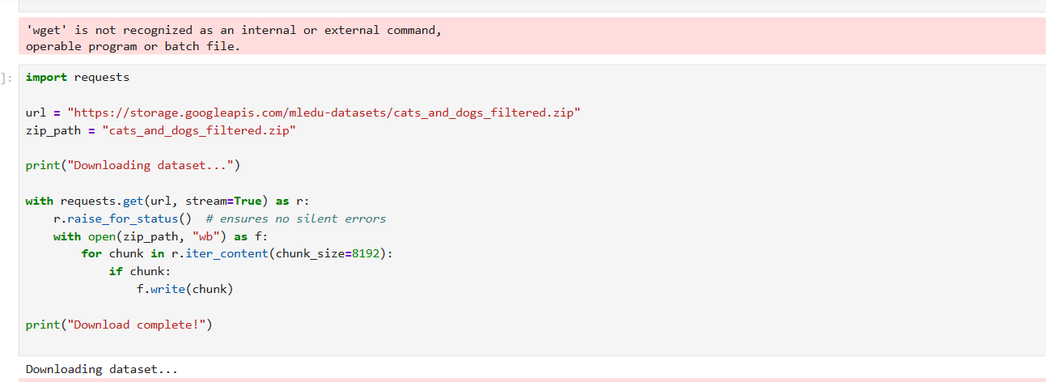

Error : Forbidden for URL (dataset Loading)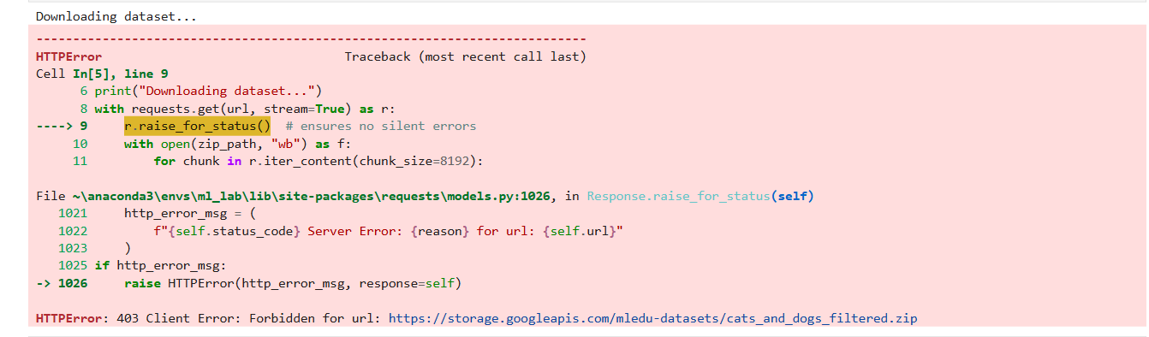
Fixing the error :
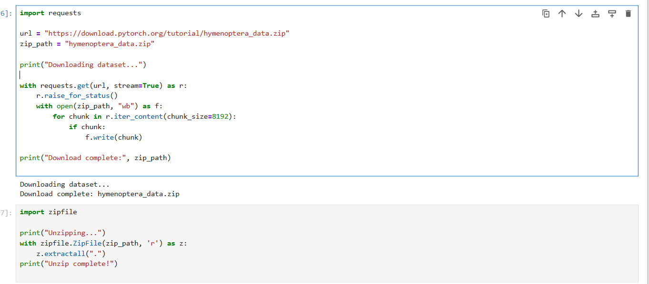
Sample Images :
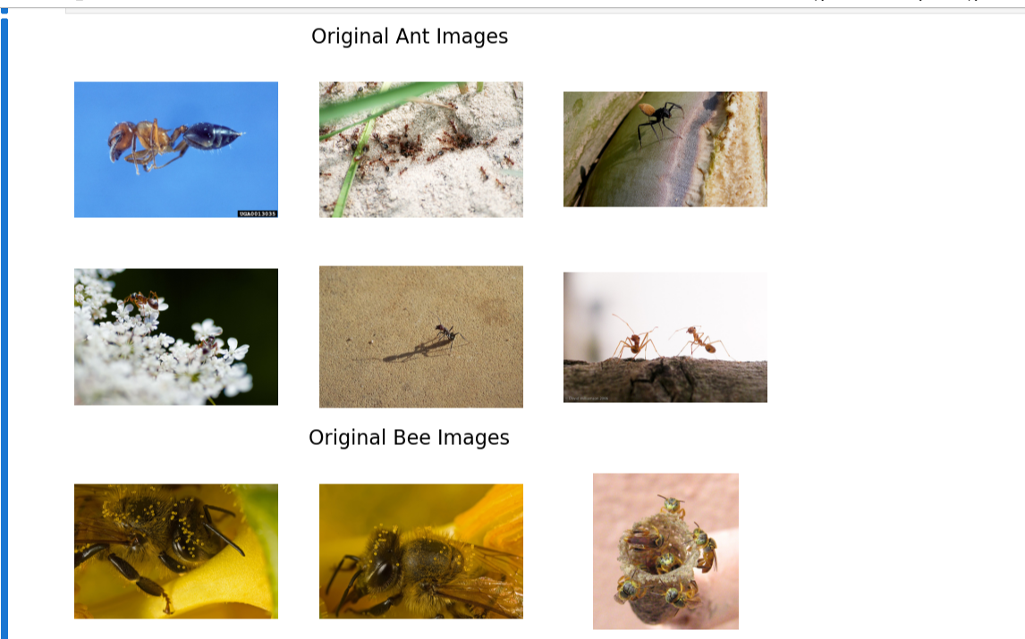
Original Image Size and Resize :
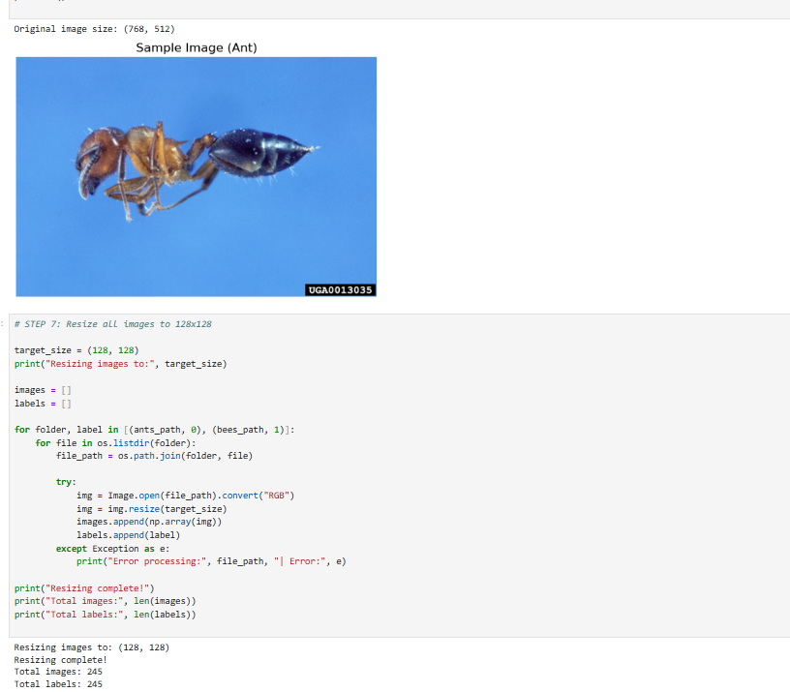
Name Error : 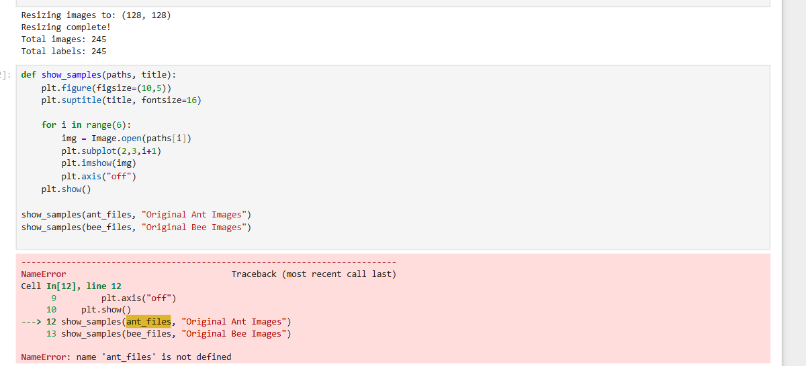
Fixing it : finding the actual name of samples by “%whos: Command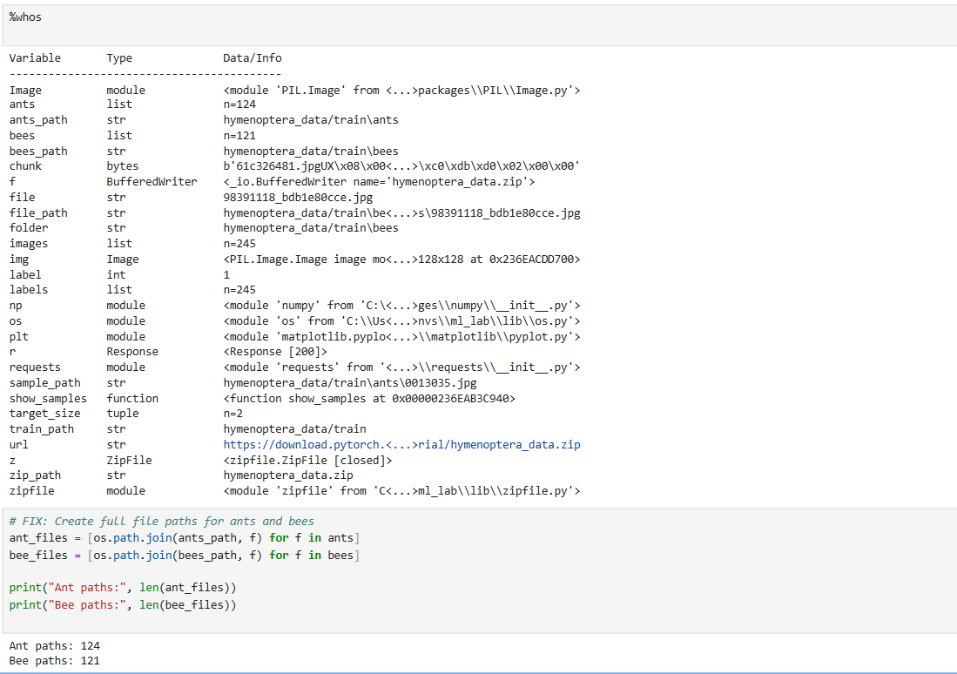
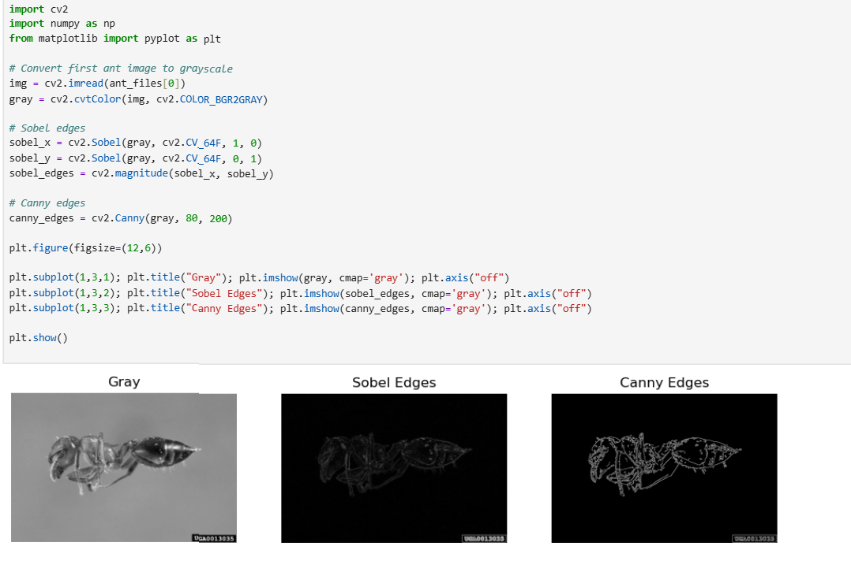

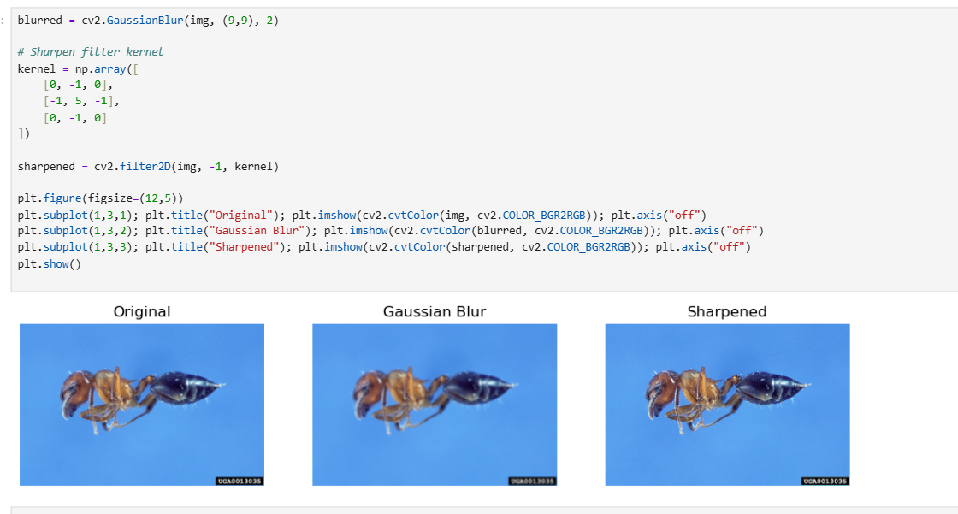

Error while PCA decomposition : ‘X_norm is not defined’
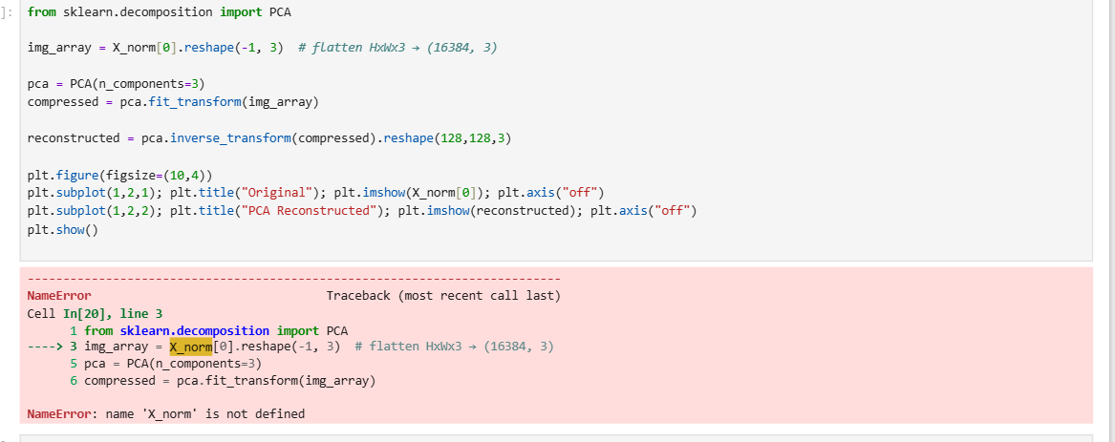

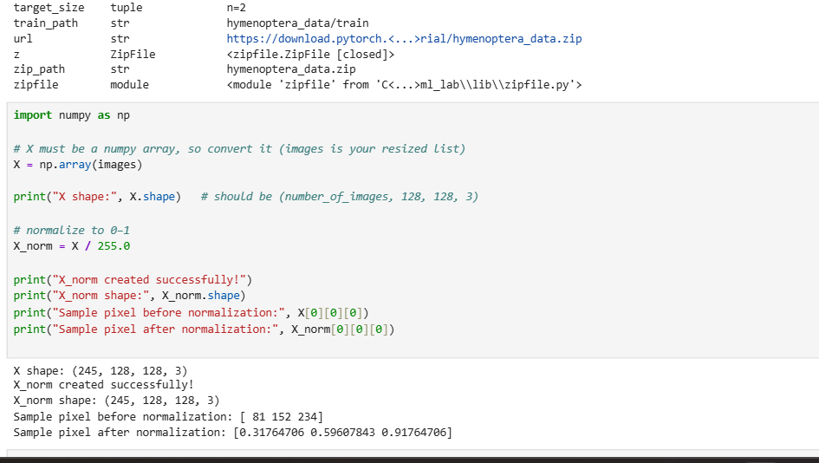
Fixing it :
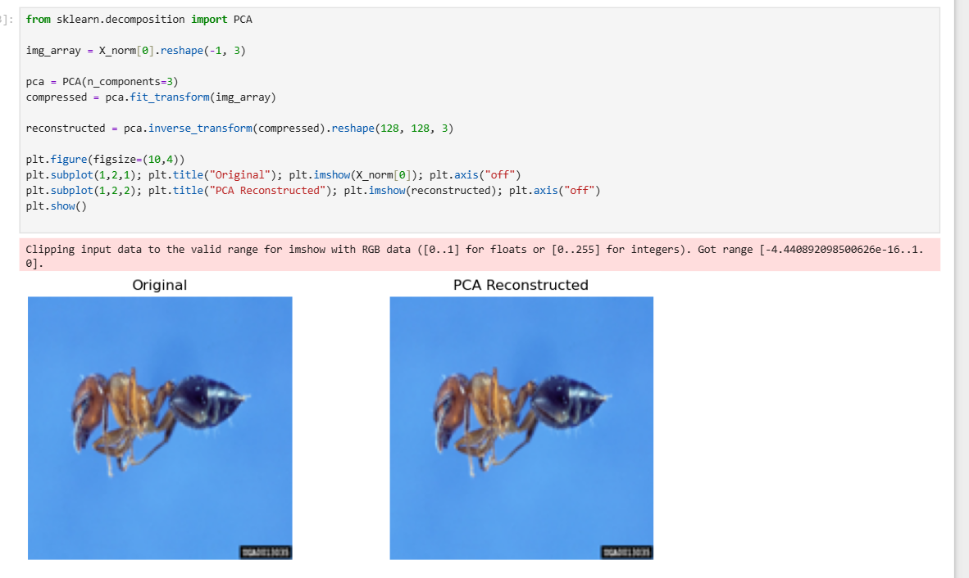
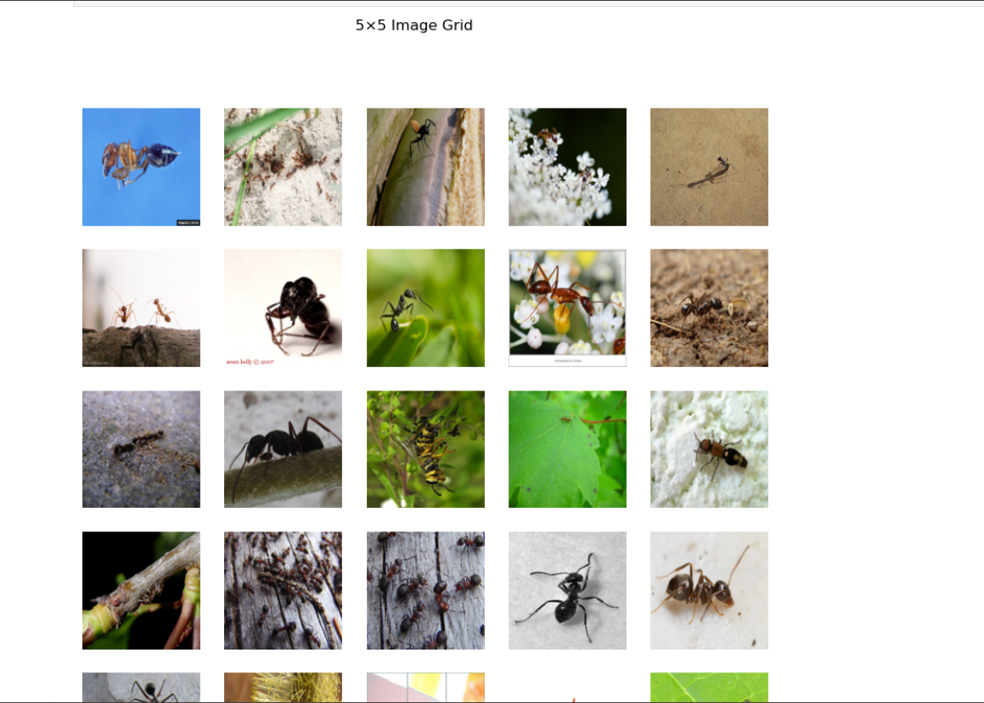
Importing pytorch and torchvision: PyTorch Dataset + DataLoader
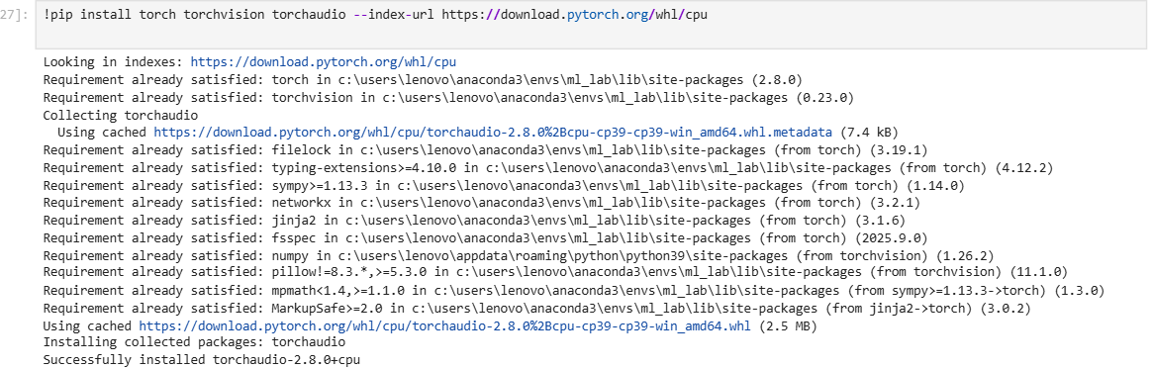
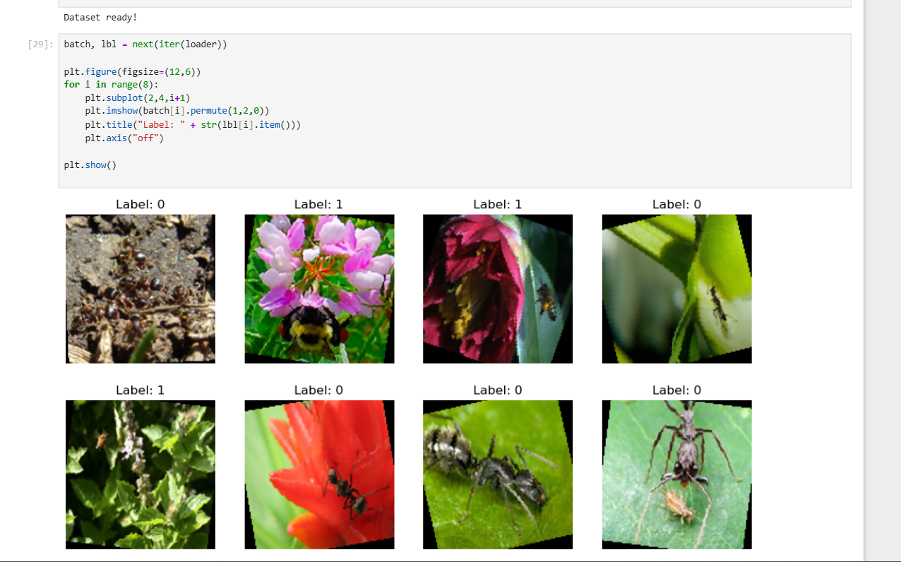
Feature 1 — CLAHE (Adaptive Histogram Equalization)

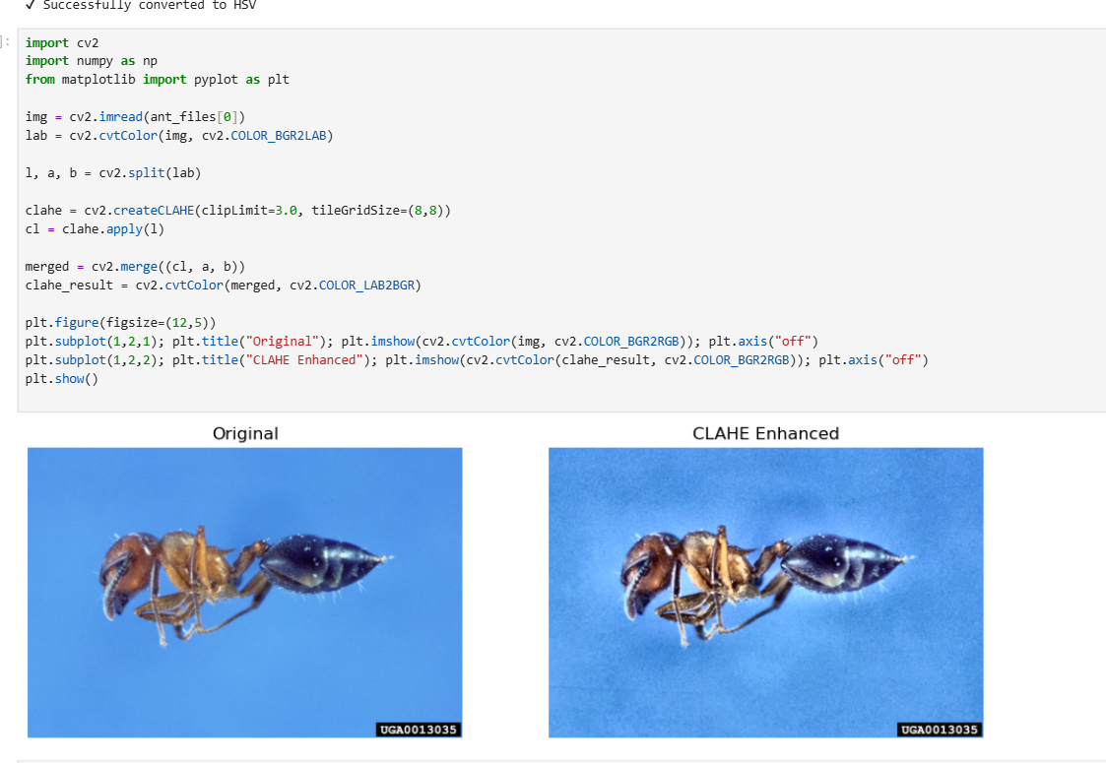
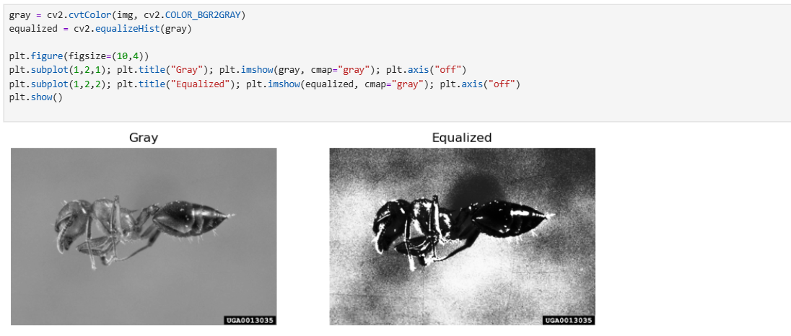
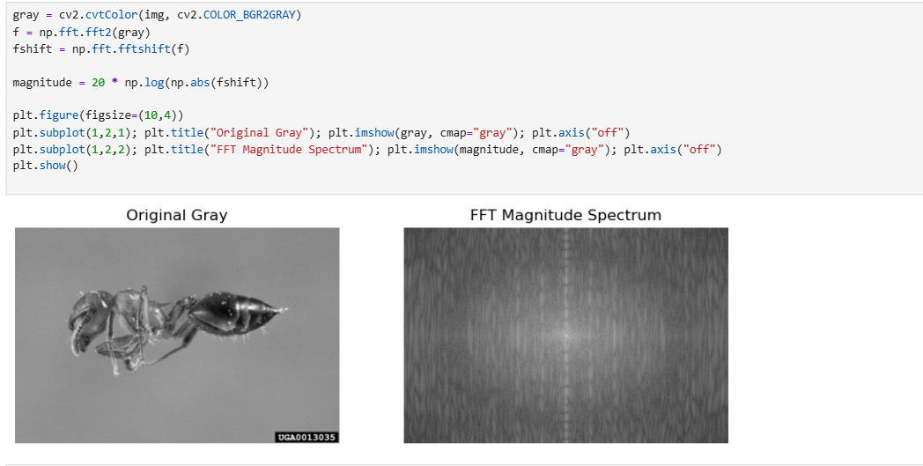
K- means segmentation :

